*HARSH KASHYAP  
CSE 4*

*101917088*

[*hkashyap_be19@thapar.edu*](mailto:hkashyap_be19@thapar.edu)

**PRACTICAL COMPUTING**



Submitted to

Aashima Sharma

**__________________________________________**

**Practical Computing LAB**

**Assignment 2**

**Question 1**

**What command is used on Linux to change the group of a file or directory?**

**Solution -**

In Linux, each file is associated with an owner and a group and has permissions that determine which users may read, write, or execute the file. Unlike the chown command that allows you to change the user and group ownership, chgrp changes only the group ownership. To find out to which group the file belongs to, use the ls -l command. Regular users can change the group of the file only if they own the file and only to a group of which they are a member. Administrative users can change the group ownership of all files.

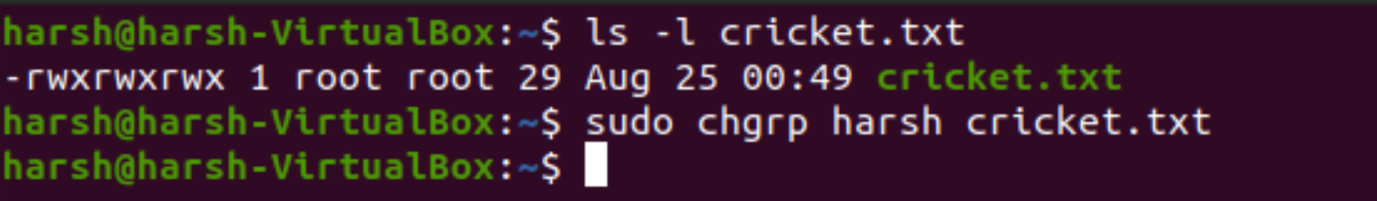

**__________________________________________**

**Question 2**

**Make sure you have all the rights to the files, and others can only read.**

**Solution**

We can have all write for ourselves by giving read write and execute permissions for ourselves and giving the others only read permission.

We can give us 7 read-write and execute and groups and others 4 so that they can only read.

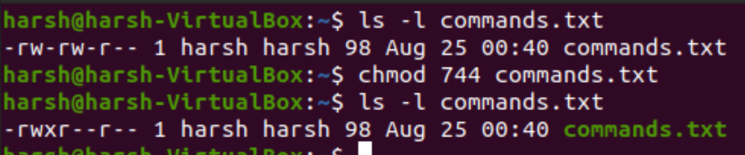

**__________________________________________**

**Question 3**

**With chmod, is 770 the same as rwxrwx---?**

**Solution**

**Yes, they both are same.**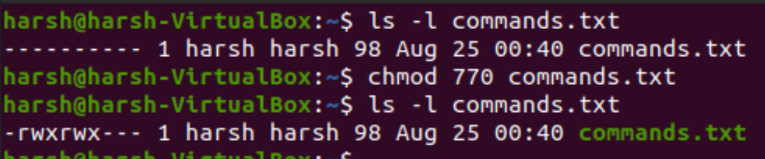

**__________________________________________**

**Question 4**

**With chmod, is 400 the same as r--------?**

**Solution -**

Yes, both are same.

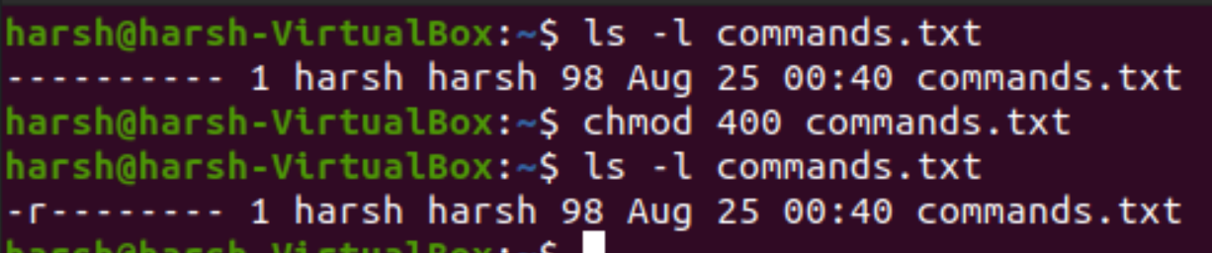

**__________________________________________**

**Question 5**

**Q5. With chmod, is 734 the same as rwxr-xr--?**

**Solution -**

No, they are different.

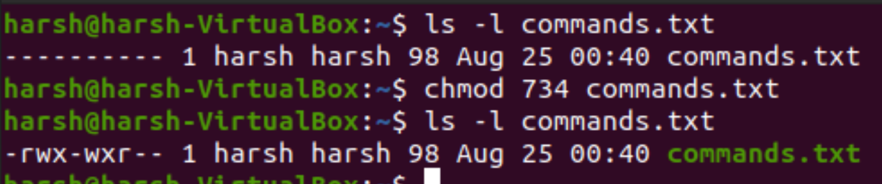

**__________________________________________**

**Question 6**

**Create a file as root, give only read to others.**

**Solution -**

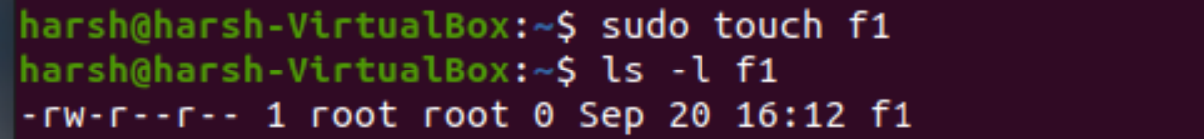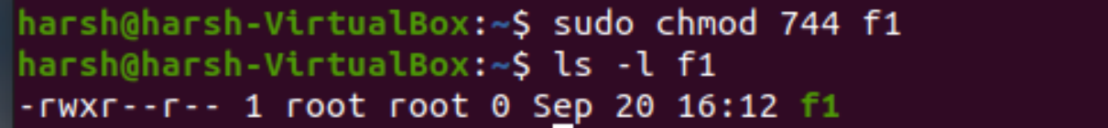

**__________________________________________**

**Question 7**

**Create a directory that belongs to a group, where every member of that group can read and**

**write to the files and create files. Make sure that people can only delete their own files.**

**Solution -**

The restricted deletion flag or sticky bit is a single bit, whose interpretation depends on the file type. For directories, it prevents unprivileged users from removing or renaming a file in the directory unless they own the file or the directory; this is called the restricted deletion flag for the directory and is commonly found on world-writable directories like /tmp.

So, to make sure that people can create and delete files but can delete their own files only, we will add 1 in chmod.

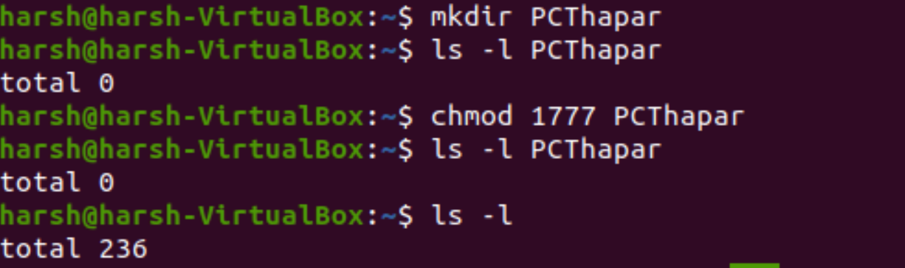



Below is the basic representation of how Linux based system allows user to delete their own files.

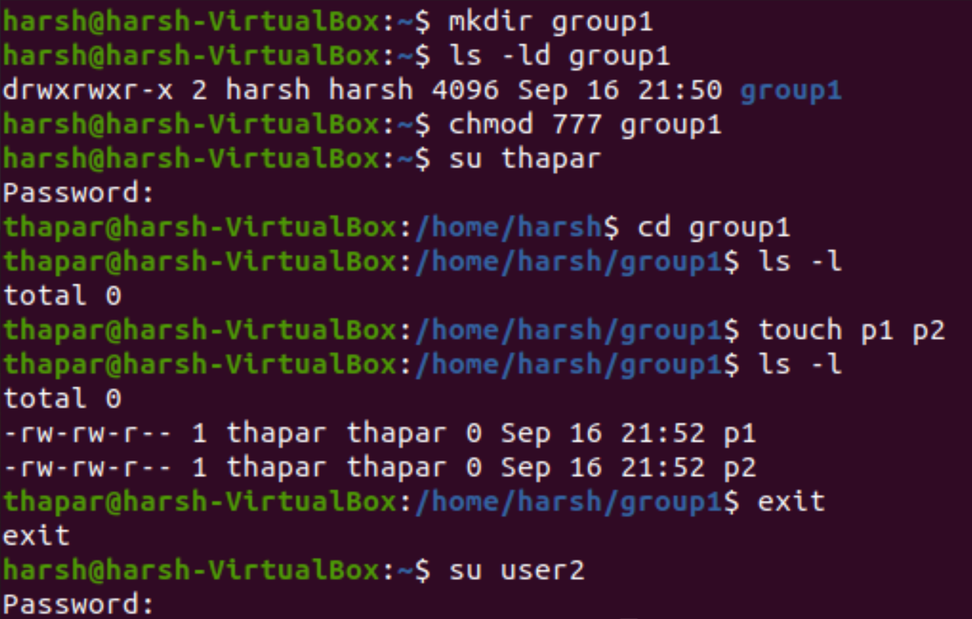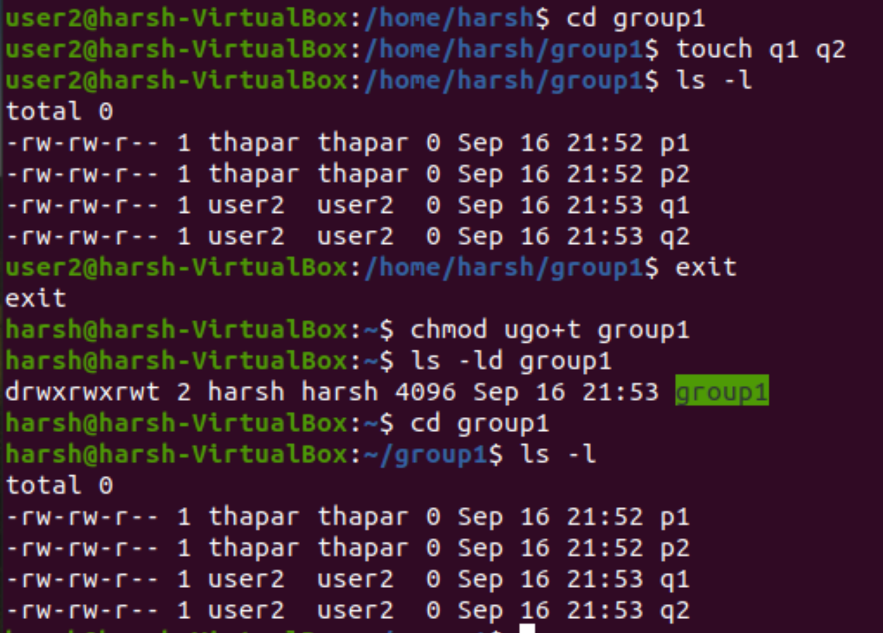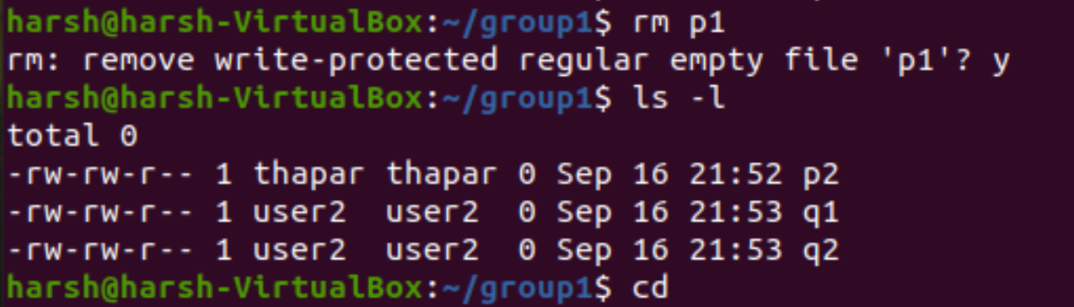

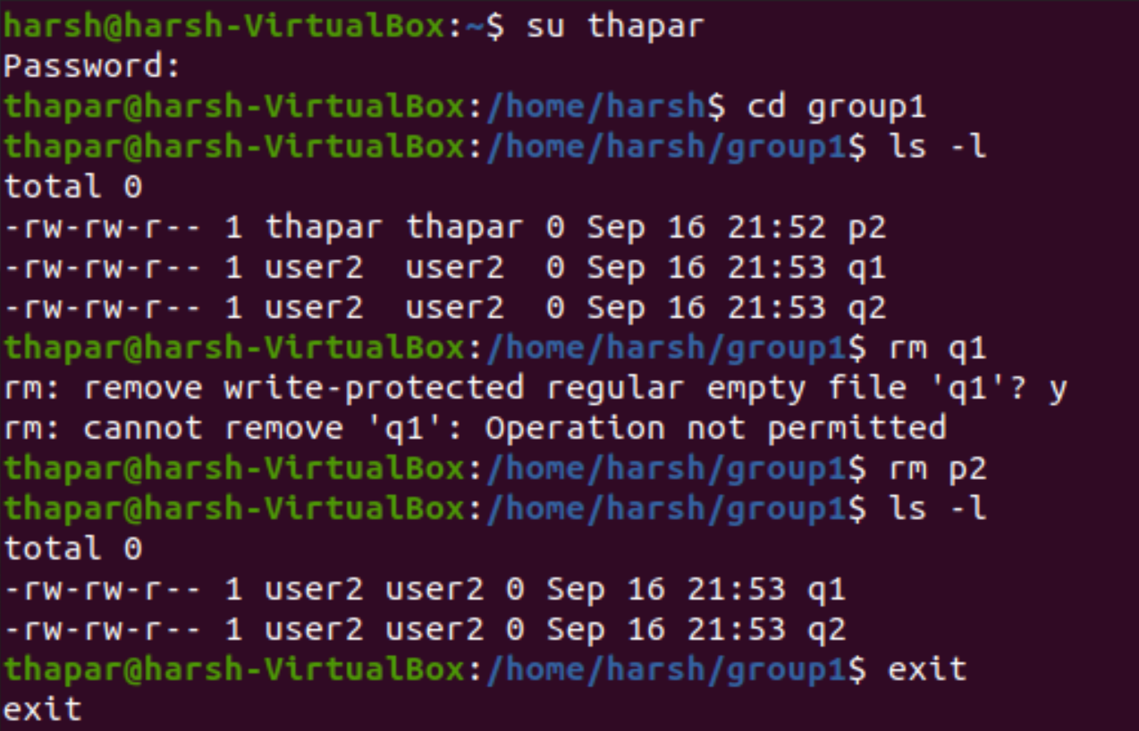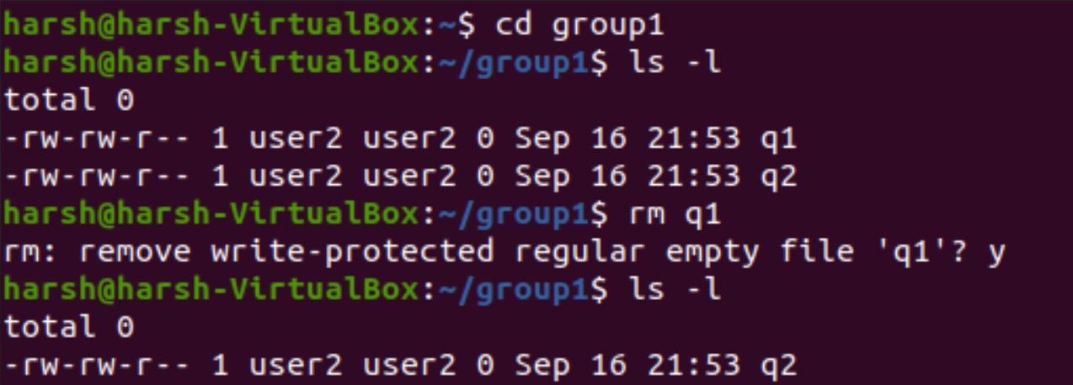

**__________________________________________**

**Question 8**

**Allow read permissions to everyone.**

**Solution -**

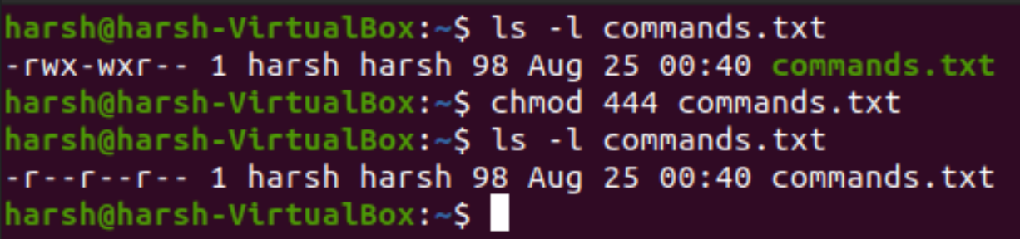

**__________________________________________**

**Question 9**

**Allow everyone to read, write and execute the files.**

**Solution -**

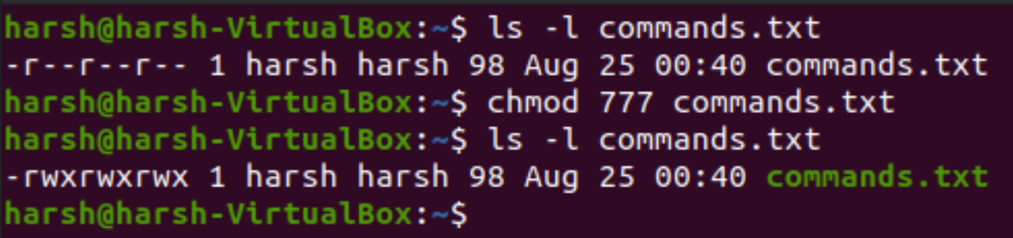

**__________________________________________**

**Question 10**

**Deny execute permission from everyone.**

**Solution -**

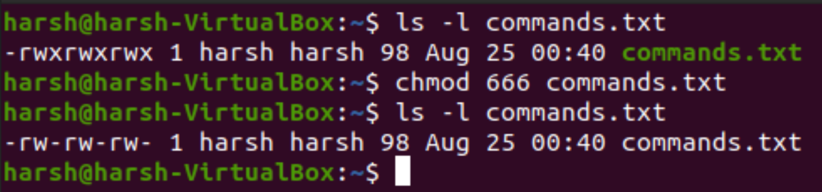

**__________________________________________**

**Question 11**

**Write permissions will the following command give: chmod 641?**

**Solution -**

This will give read and write permission to the owner, read permission to the group and execute permission to others.

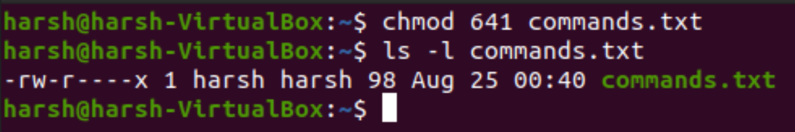

**__________________________________________**

**Question 12**

**Copy a file owned by root from /etc/ to your permissions dir, who owns this file now.**

**Solution -**



